Intercepting the traffic of SL App
Sunday, 9 February 2025
16:38

- Start Burp Suite:
  - Open Burp Suite and configure the proxy to listen on 127.0.0.1:8080 or another preferred port.
- Export Burp CA Certificate:
  - Go to Proxy → Options → CA Certificate.
  - Downloaded the certificate in der format
  - Then push the certificate to android using
  - Command : adb push certificate.crt /mnt/sdcard/
- Configure Proxy on Android:
  - On your device, go to WiFi settings → Modify network → Advanced options.
  - Set Proxy:
    - Proxy Hostname: 10.0.2.2
    - Manual
    - Proxy Port: 8080.

Step 2: Install and Configure Frida

- pip install frida frida-tools
For transferring to the device: adb push frida-server /data/local/tmp/
- Set permissions and start the server:
adb shell
cd /data/local/tmp
chmod +x frida-server ./frida-server &
- Testing frida connection: frida-ps -U

Step 3: Attach to the App and Disable SSL Pinning

- For finding the package name: adb shell pm list packages | findstr sl

- Attaching the app using objection

Install Objection : pip install objection

- Start the app and attach objection: objection -g com.sl.SLBiljetter explore
- Then disable SSL pinning: android sslpinning disable

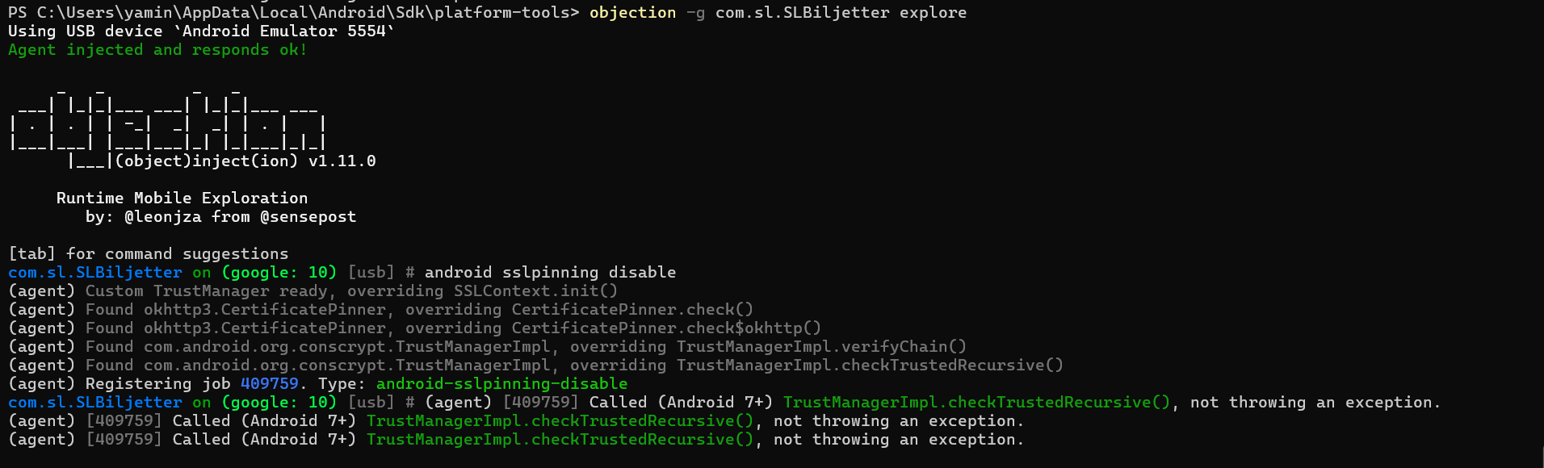

And in the Burp Suite I can see the traffic is intercepted without any errors.

